**Collecting Dataset:**

1. Download ChipWhisperer local installer from <https://github.com/newaetech/chipwhisperer>
2. Connect the ChipWhisperer and the measure pin for capturing the traces.
3. 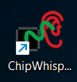Open chipwhispere-jupyter exe file
4. Paste the simpleserial-nn folder in **hardware/firmware** and move “MyCWCD_with_automation.ipynb”

To the **/** folder.

1. 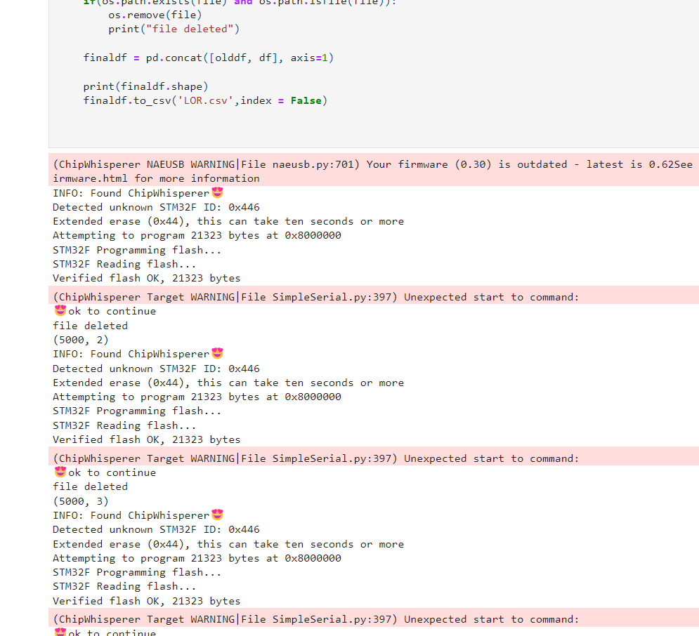If the program runs properly, it’ll start capturing the dataset traces.

If we want more data we can change the number of times we run the for loop. Like this,

**for** i **in** range(num): **Here, change the num.**

1. **Change the name of the csv file according to the algorithm we’re running**
2. 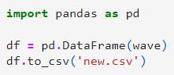from **/Created_Large_Datasets/** and run csvOpert.ipynb.
3. Run all notebooks from transposed and transposed with labels folders then FINAL DATA randomized will be created in FINAL_DATASET folder.

**Classification Model:**

* Install miniconda <https://docs.conda.io/en/latest/miniconda.html> and then pip install pandas , pip install tensorflow.
* From **/Created_Large_Datasets/FINAL_DATASET** folder , run the Classification model file to create and analyse the neural network with accuracy and loss curves.